|  |  |  |  |  |
| --- | --- | --- | --- | --- |
|  |  | | | |
|  | |  | | |
| Project: | | Personal Health Monitoring System (PHMS) | | |
| Team No.: | | 3 | | |
| Class: | | CSE 3310; Spring 2017 | | |
| Module: | | System Requirements Analysis (SRA) | | |
| Deliverable: | | SRA Document | | |
| Version: | | [1.0] | Date: | [03/23/2017] |

Contributors:

Prapti Bhaukajee

Saja Abualfoul

Kristoffer Edgard Jorge-Munoz

MD Ibrahim Khalil

Revision History

| Version number | Date | Originator | Reason for change | High level description of changes |
| --- | --- | --- | --- | --- |
| 1.0 | 03/23/2017 | Prapti Bhaukajee  Saja Abualfoul  Kristoffer Edgard Jorge-Munoz  MD Ibrahim Khalil | Initial draft |  |
|  |  |  |  |  |
|  |  |  |  |  |
|  |  |  |  |  |

TABLE OF CONTENTS

1. Introduction and Project Overview 3

2. Objectives 4

2.1 BUSINESS Objectives 4

2.2 SYSTEM Objectives 4

3. Project Context Diagram 5

4. Systems Requirements 6

4.1 “Registration” Requirements 6

4.2 “Data Maintenance” Requirements 6

4.3 “Search” Requirements 6

4.4 “Diet” Requirements 6

4.5 “Vital Signs” Requirements 6

4.6 “Medications” Requirements 6

4.7 “Alerts” Requirements 6

4.8 “Communication” Requirements 6

4.9 "Management Data" Requirements……………………………………………………………….6

4.10 "Notes" Requirements…………………………………………………………………………….6

5. Software Processes and UML Diagrams 7

5.1 Hardware and Infrastructure 7

5.2 UML Diagrams 7

5.3 Test Plan 7

5.4 Screen Shots 7

6. Assumptions and Constraints 8

6.1 ASSUMPTIONS 8

6.2 CONSTRAINTS 8

6.3 Out of Scope material 8

7. Delivery and Schedule 9

8. Stakeholder Approval Form 10

Appendix: 11

# 1. Introduction and Project Overview

For this project, our group was assigned to develop an android application that will help users maintain various personal health-related data. The PHMS application will be used to keep track of one’s vital signs, daily medicine intake, or following a diet regiment.

# 2. Objectives

## 2.1 BUSINESS Objectives

The following is a list of business objectives:

**Objective 1**: Registration: System will capture the following personal information:

Last name, middle name {optional}, first name

Phone number home, cell

E-mail address

Physical address.

**Objective 2**: Vital signs:

**Objective 3**: Medication:

**Objective 4**: Diet:

**Objective 5**: Notes:

**Objective 6**: Login:

**Objective 7**: Search:

**Objective 8**: Monitoring system:

**Objective 9**: Communication:

**Objective 10**: Data Maintenance:

## 2.2 SYSTEM Objectives

The following is a list of system objectives:

**Objective 1**: System will be an android application for mobile platform

**Objective 2**: SQLite will be used as the database or whatever your database is

.

.

**Objective M**:

# 3. Project Context Diagram

Context Diagram

Registration

Management Data

Medication

Vital Signs

Communication

Notes

Search

Login

Alert/ Monitoring

Diet

# 4. Systems Requirements

{Provide a Requirements overview by introducing the following requirement sections that correspond with the “user” functionality. There should be a 1-1 correspondence between your requirements sections below, your context diagram, your Business Objectives and your UML diagrams. Keep hardware, database, test data, and android versions to section 5. Add a new section for each category of your requirements. This is the heart of the SRA document, and hence the lengthiest, and should list all requirements of the system. **Please use the designated Requirements Form.**}

## 4.1 “Registration” Requirements

{List requirements}

## 4.2 “Data Maintenance” Requirements

{List requirements}

## 4.3 “Search” Requirements

|  |  |
| --- | --- |
| **Requirement Title:** | Search |
| **Sequence No:** | 2 |
| **Short description:** | Search for stored or general data |
| **Description:** | There must be a button labeled as “Search” where the user can search for something specific or general. |
| **Pre-Conditions**: | User must be logged in |
| **Post Conditions:** | A list that will display the information needed. |
| **Other attributes:** | N/A |

## 4.4 “Diet” Requirements

|  |  |
| --- | --- |
| **Requirement Title:** | Diet |
| **Sequence No:** | 001 |
| **Short description:** | Keep Track of user’s food intake. |
| **Description:** | The system shall have a box where the user will enter their diet. The box should be labeled as “Enter Diet”. The user will be able to choose their diet based on their health issues. |
| **Pre-Conditions**: | The user will have signed in already. |
| **Post Conditions:** | The user will select their health issue and diet. |
| **Other attributes:** | There must be a button labeled “Go” that will attempt to record the user’s input. |

|  |  |
| --- | --- |
| **Requirement Title:** | Diet |
| **Sequence No:** | 002 |
| **Short description:** | Contacts a doctor |
| **Description:** | Once the user has selected their diet and health issue, the user will be able to notify the doctor. The doctor will check if the specific diet will be good if not he will notify the user to change their diet. |
| **Pre-Conditions**: | The user should have selected their health issue and diet |
| **Post Conditions:** | Doctor will notify the user if their diet is good or not. |
| **Other attributes:** | There should be a button labeled “notify doctor” that will attempt to contact doctor. |

## 4.5 “Vital Signs” Requirements

{List requirements}

## 4.6 “Medications” Requirements

{List requirements}

## 4.7 “Alerts” Requirements

{List requirements}

## 4.8 “Communication” Requirements

|  |  |
| --- | --- |
| **Requirement Title:** | Communication |
| **Sequence No:** | 001 |
| **Short description:** | Check for phone number |
| **Description:** | User will enter their phone number using numbers 0-9. The system will check if the number provided is valid or not. If number is valid it will add it to the system else, it will ask the user to re-enter their number. |
| **Pre-Conditions**: | User must be logged in. |
| **Post Conditions:** | If number is valid a “valid number” message should pop up. |
| **Other attributes:** | N/A |

|  |  |
| --- | --- |
| **Requirement Title:** | Communication |
| **Sequence No:** | 002 |
| **Short description:** | Check for email address |
| **Description:** | User will enter their email address using a valid email address. The system will check if the email is valid or not. If email address is valid, email will be added. Else, it will ask the user to re-enter their email address. |
| **Pre-Conditions**: | User must enter a valid email address. |
| **Post Conditions:** | If email address entered by the user is valid a “valid email address” message should pop up. |
| **Other attributes:** | N/A |

# 5. Software Processes and UML Diagrams

## 5.1 Hardware and Infrastructure

This is a mobile app using android platform.

## 5.2 UML Diagrams

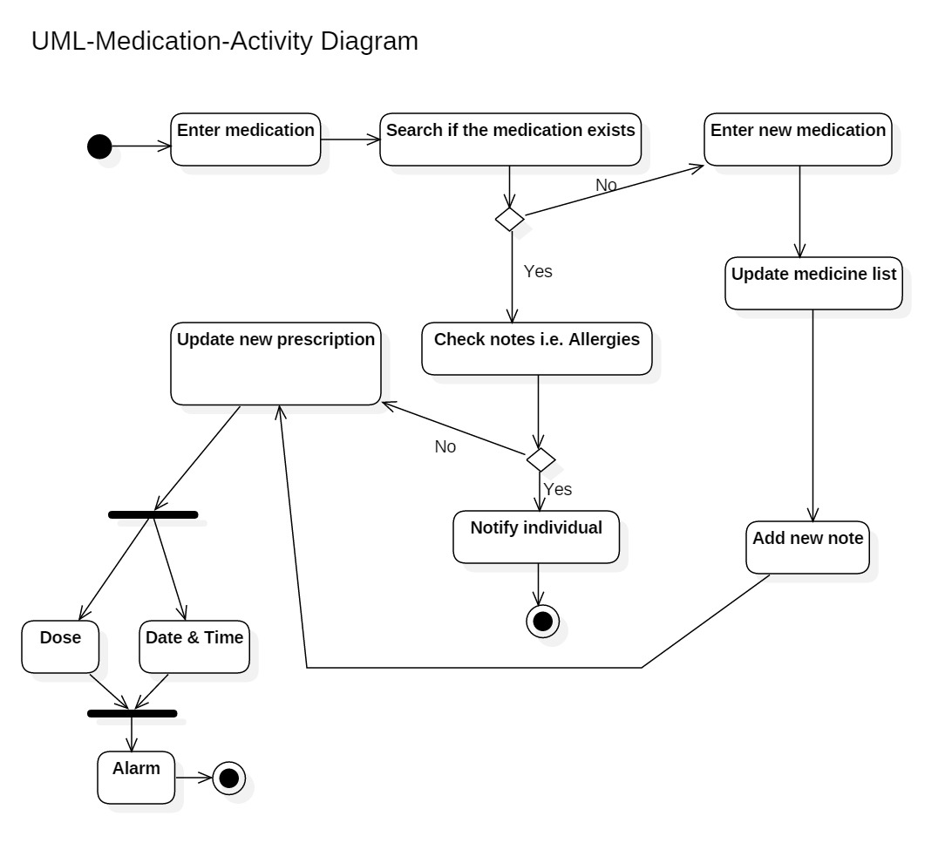

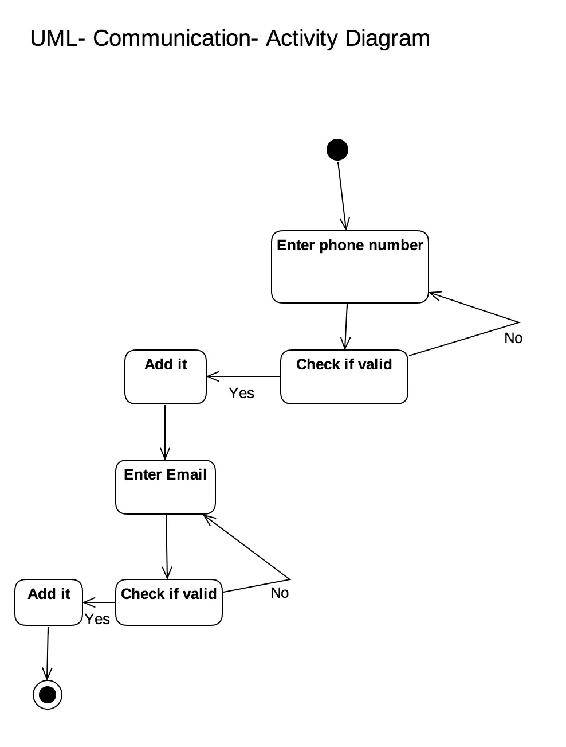

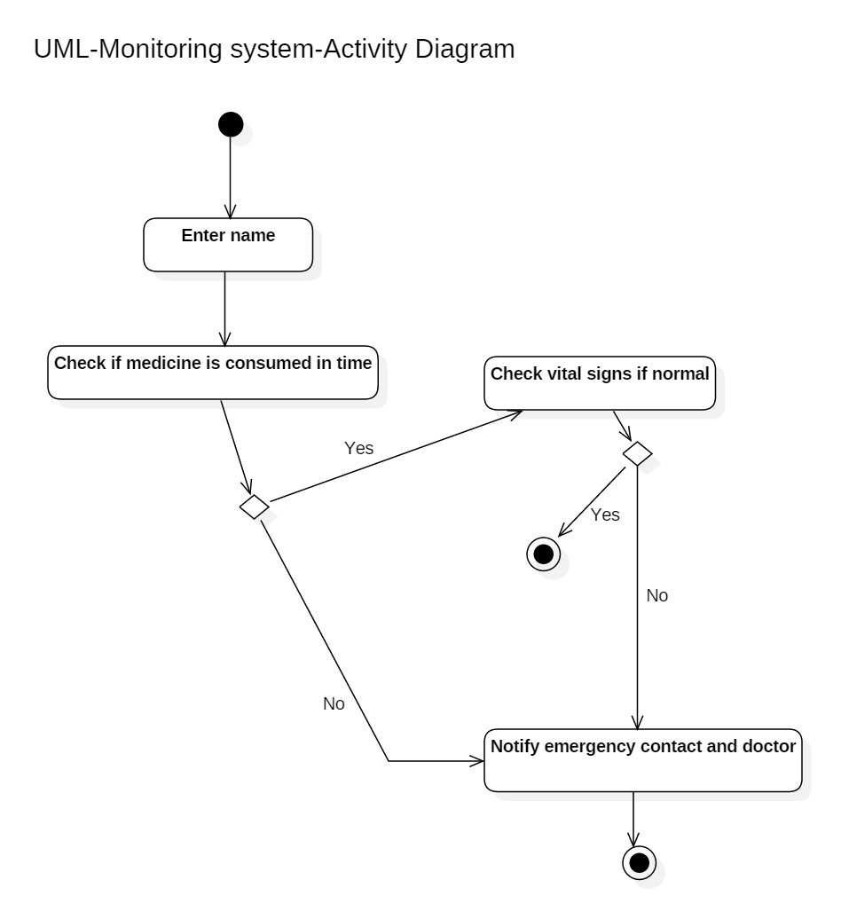

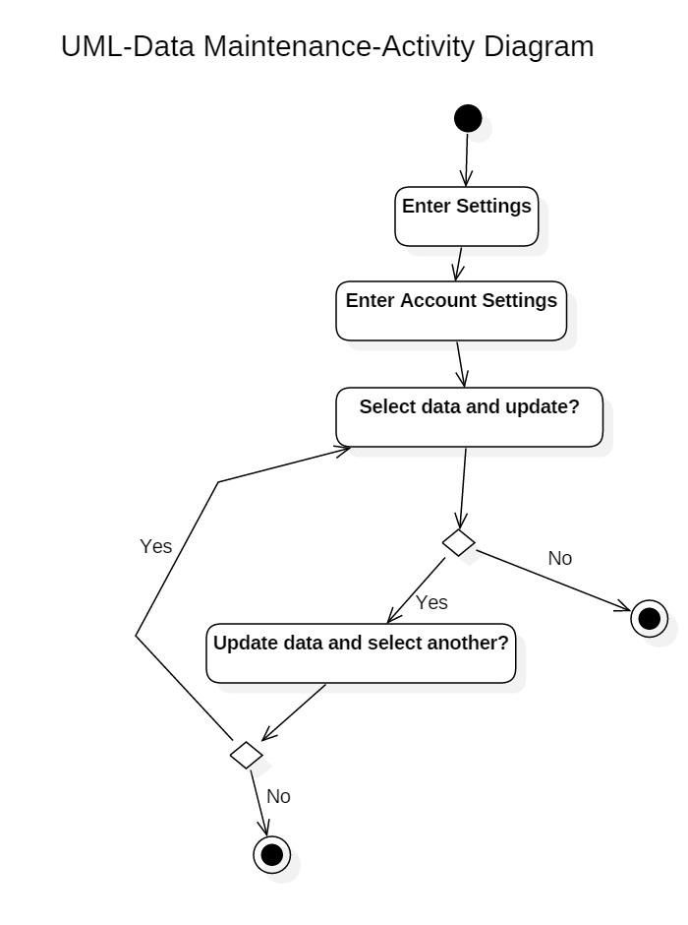

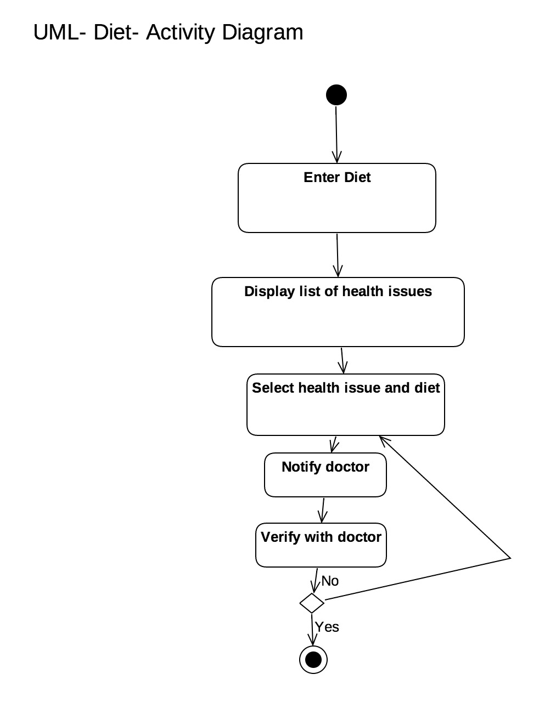

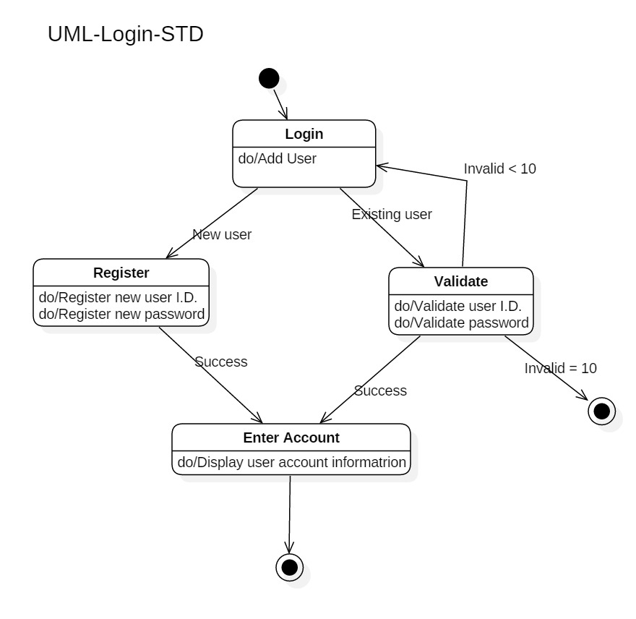

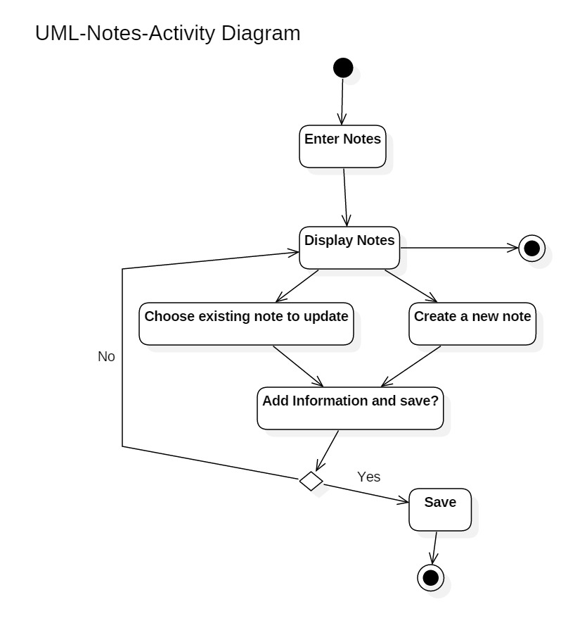

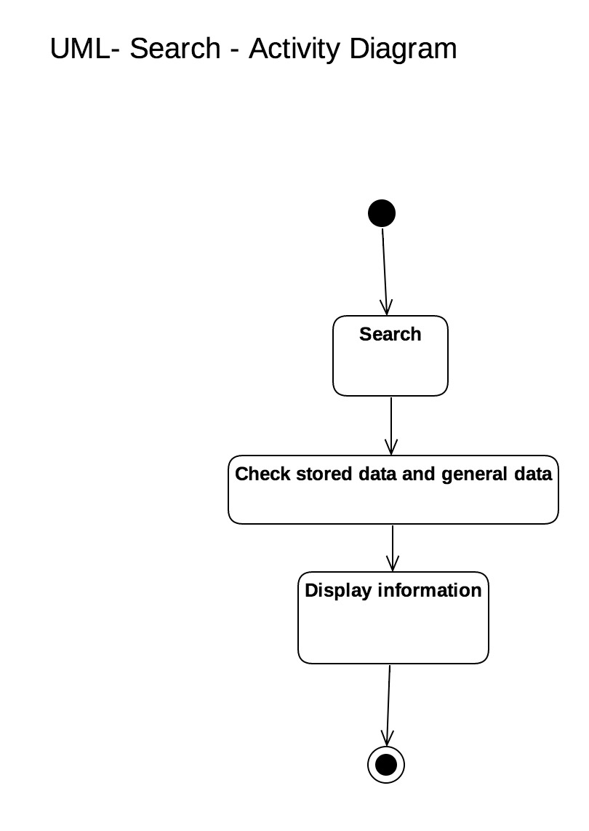

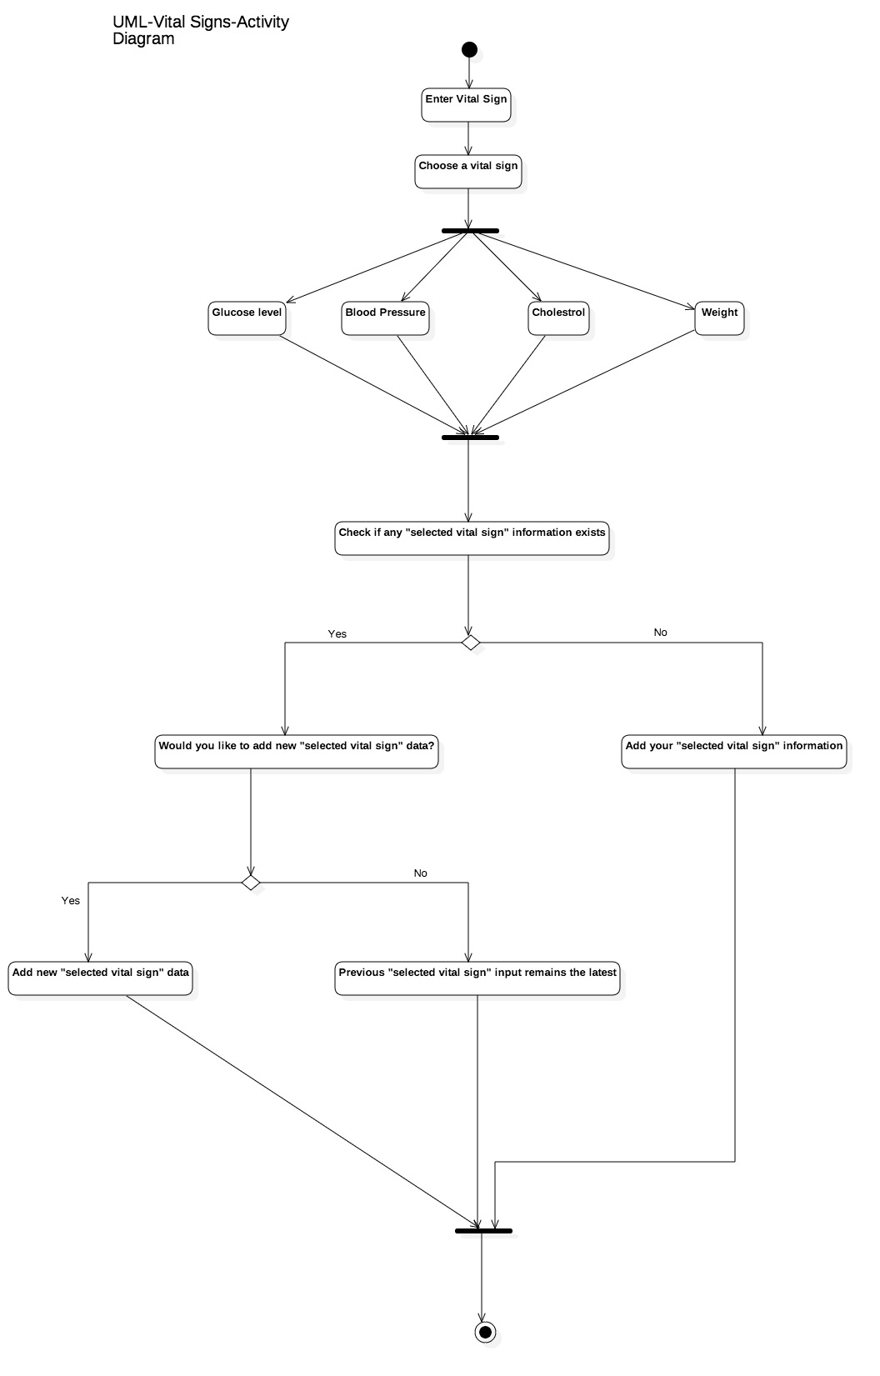

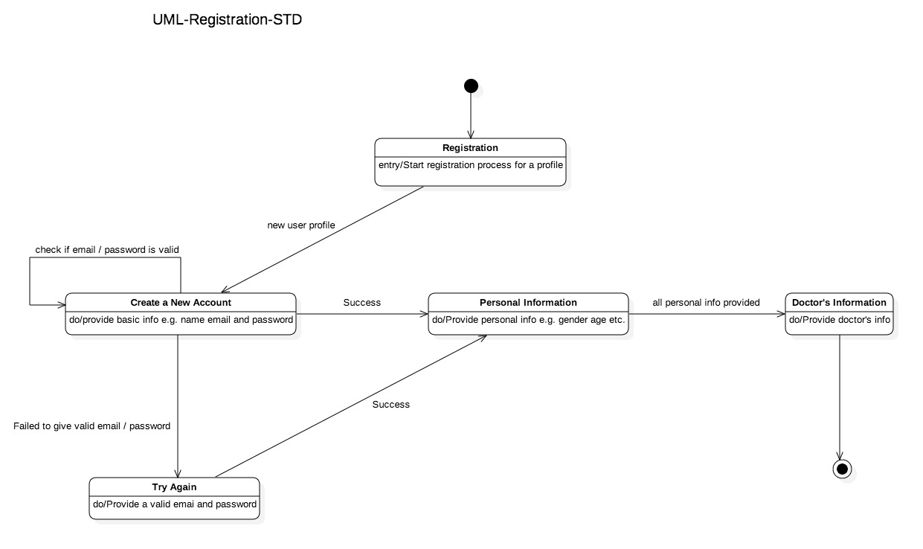

## 5.3 Test Plan

A Test Plan will be provided at a later stage.

## 5.4 Screen Shots

No screen shots available at this time.

# 6. Assumptions and Constraints

## 6.1 ASSUMPTIONS

The following is a list of assumptions:

* Only people older than 18 can use this product
* Only people with not very serious health issues can use this product.

## 6.2 CONSTRAINTS

The following is a list of constraints:

* Team lacks android development skills

## 6.3 Out of Scope material

The following is a list of “out of scope” material:

* Post Project maintenance is not covered

# 7. Delivery and Schedule

{List all tasks/milestones from start of the project to the end with specific dates for both Anticipated Start & End Dates

|  |  |  |  |  |
| --- | --- | --- | --- | --- |
| Task/Milestone Description | Anticipated Start Date | Anticipated End Date | Status | Comments |
| Prepare UML diagrams | 2/1/2016 | 2/23/2017 | Complete | UML diagram delivered  Increment 1 Deliverable |
| SRA document (Includes project objectives, Requirements and UML diagrams) | 3/1/2017 | 3/23/2017 | In Progress | Deliverable will be the SRA document. All stakeholders agree on the content of the SRA by signing in section 8.  Increment 2 Deliverable |
| Design: Design big picture, define format, navigation and functionality to include | 3/21/2017 | 4/13/2017 | To Be Completed (TBC) |  |
| Implementation: Home screen design | 3/28/2017 | 4/13/2017 | TBC |  |
| Implementation: Login and registration | 3/28/2017 | 4/13/2017 | TBC |  |
| **…**  **List all required functionality and tasks**  **…** | ? | ? | ? |  |
| Test case design | 3/21/2017 | 4/13/2017 |  | Increment 3 Deliverable |
| External Documentation (i.e. User Manual) | 4/15/2017 | 5/1/2017 |  |  |
| Project presentation | 4/20/2017 | 5/4/2017 |  |  |
| Final Milestone: project delivery |  | 5/4/2017 |  | Increment 4 Deliverable |

# 8. Stakeholder Approval Form

|  |  |  |  |
| --- | --- | --- | --- |
| Stakeholder Name | Stakeholder Role | Stakeholder Comments | Stakeholder Approval Signature and Date |
| Bahram Khalili | Development Mgr |  |  |
| Akshit Singhal | Project Assistant |  |  |
| Saja Abualfoul | Developer |  |  |
| Prapti Bhaukajee | Developer |  |  |
| Kristoffer Edgard Jorge-Munoz | Developer |  |  |
| MD Ibrahim Khalil | Developer |  |  |

# Appendix:

None.